Shanlin Hu

A15754205

Part1 :

Summary:

Create a website that identifies my skills, various experiences, and career. Creating a website can help me put all the information in a single, easily understandable format that provides viewers an insight into who I am.

Persona diagram:

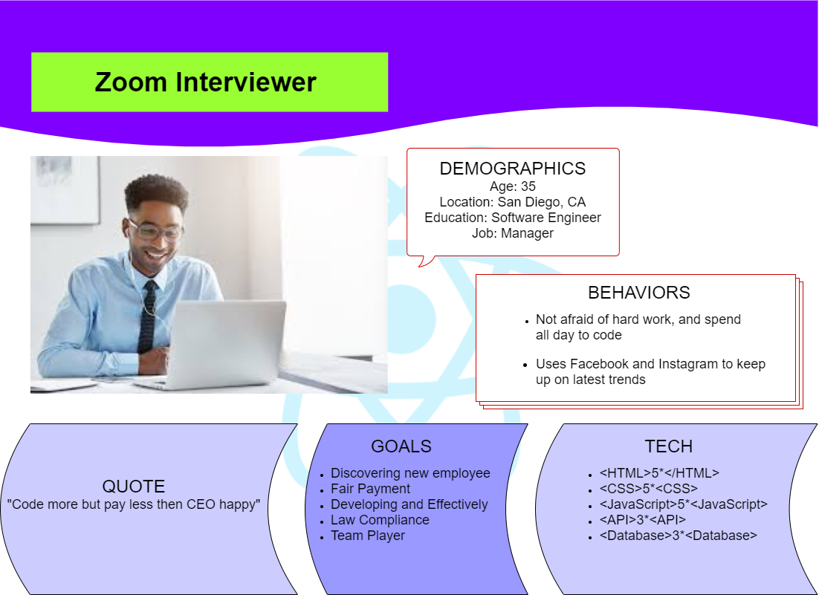

Site diagram:

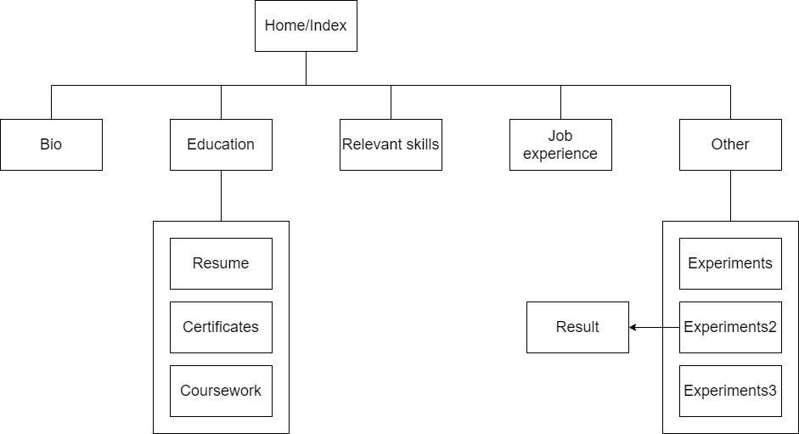

Wireframe:

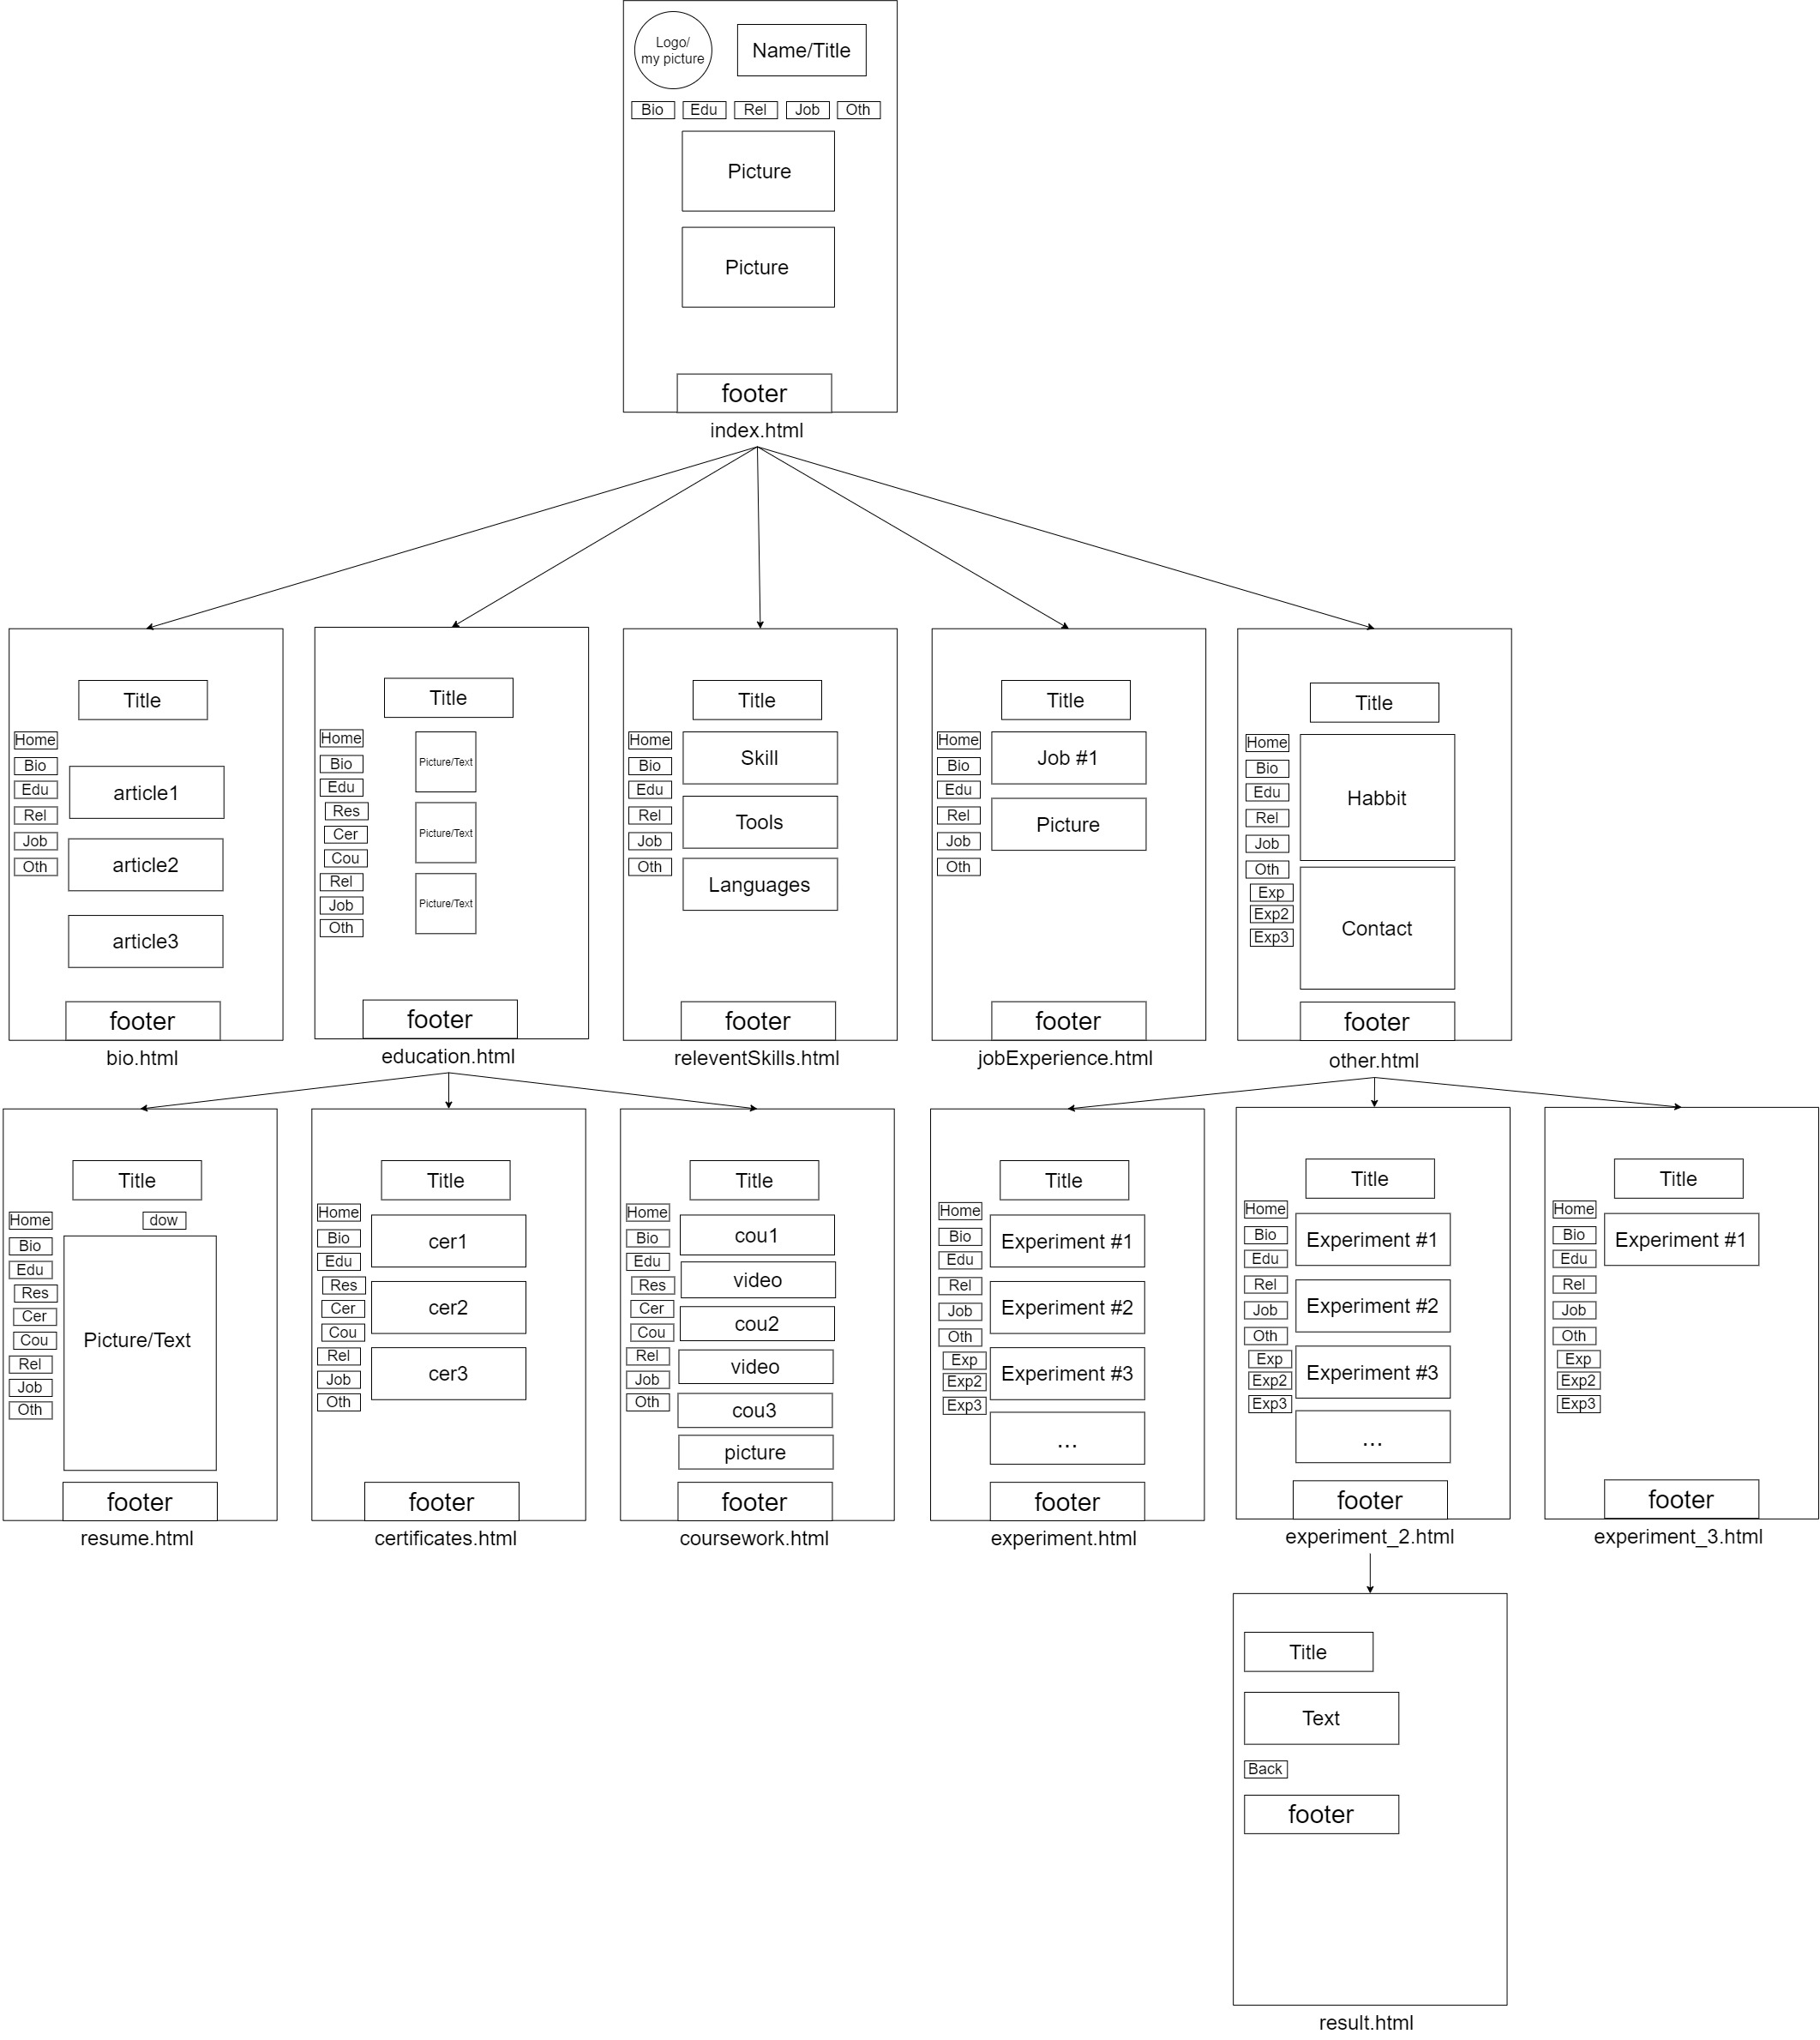

Technical requirements:

1. Target Browsers: Chrome, Firefox, IE
2. Hosting: Firebase
3. Website address:<https://cse134b-bb87d.web.app/index.html>
4. Recommend JavaScript enabled. Most functionality works with no JavaScript
5. Device profiles: Win10
6. Page delivery targets in bytes: less than 100kb
7. Screen resolution: should work for most screen resolutions
8. Speed: Should less than one second
9. Device: Desktop mainly
10. Mouse and keyboard required

Content requirements:

1. Home/Index:

* welcome text
* logo/my picture

1. Bio:

* articles about when I was in high school, colleges

1. Education:

* Resume
  + text about resume
  + picture of resume
  + can download the resume
* certificate
  + text about certificat
  + pictures of diploma
* Coursework
  + text about coursework
  + picture of project
  + video of project
* Introduction of high school, colleges...etc
* picture of high school, colleges

1. Relevant skills:

* text of skills list
* text of tools list
* text of language list

1. Job experience:

* text of different jobs

6. Other

* text about habit
* picture of habit
* text about contact
* Experiment
  + text about different tags
* Experiment-2
  + text about different tags
    - result-page
      * text
* Experiment-3
  + text about different tags

Part 2:

Firebase hosting

Link: <https://cse134b-bb87d.web.app/index.html>